Screener
Pausing and Restarting Screener
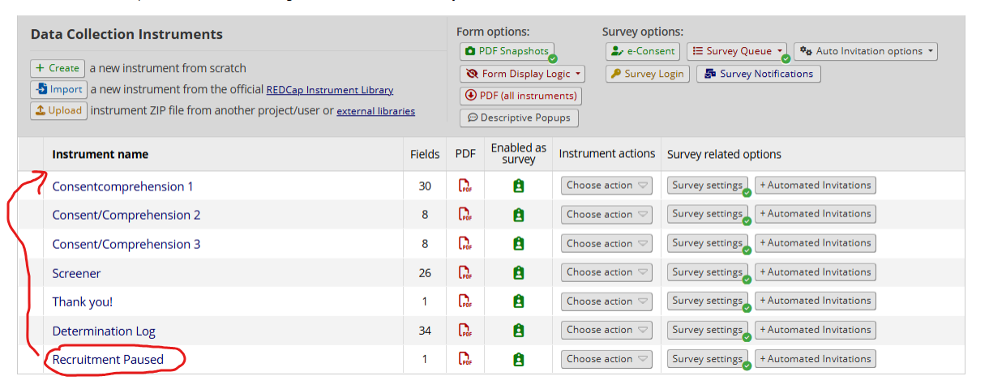
- To pause the screener, move the ‘Recruitment Paused’ instrument to the top of the Designer.
- To restart the screener, move the instrument back to the bottom.
NOTE: Make sure that the survey link has changed when shifting instruments

Ineligibility Alert
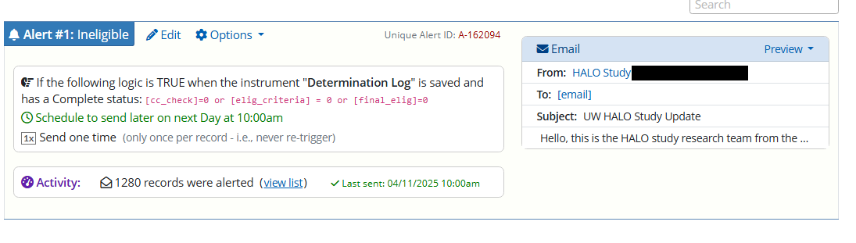
This alert in ‘Alerts and Notifications’ triggers when the Determination Log has been saved with ‘Complete’ status.
If they failed all 3 consent/comprehension questions, didn’t meet eligibility criteria, or were marked as ineligible by the RC, they will be automatically sent an email letting them know.
NOTE: The ineligibility alert is deliberately delayed rather than sent immediately. An instant response tells a respondent exactly which answer disqualified them, which makes it trivial to re-enter the screener with adjusted answers. Set the delay to suit the study.

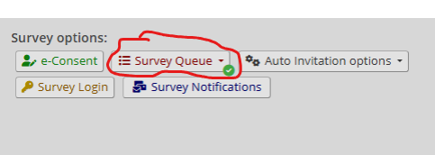
Survey Queue
You can set the Survey Queue in Designer.
Individuals will see the second consent/comprehension quiz if their score is != 9 in the first one (and the third if their score is != 9 in the second).
They will only get to the Screener if they score 9 in one of the previous three consent/ comprehension quizzes.
Everyone then receives a ‘Thank You’ message either by completing the Screener or after failing the third consent/comprehension quiz.
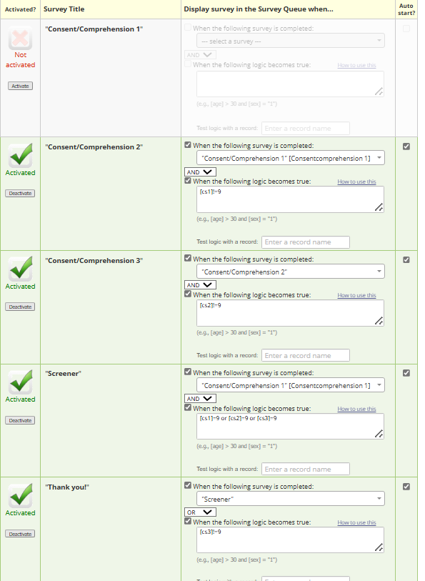

Consent/Comprehension Scoring
This is done by adding the response values of the five consent/comprehension questions. Only an exact score of 9 is accepted.
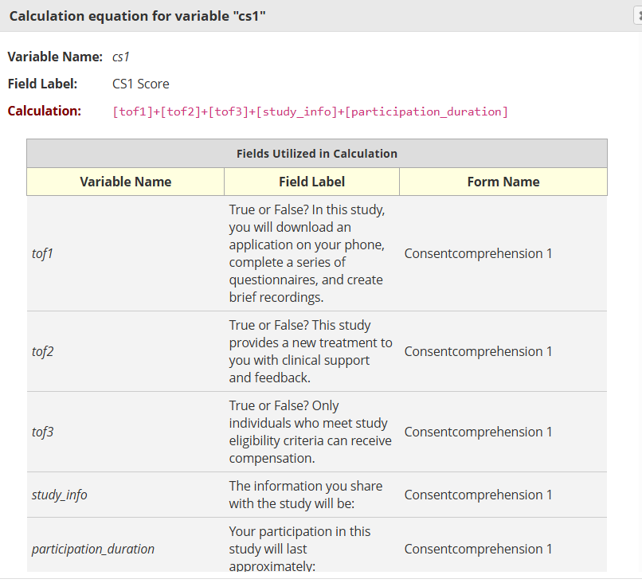
IP-Encrypt
@IP-ENCRYPT action tag reads and outputs the encrypted IP address.
@READONLY tag is used so nobody can accidentally edit the value after it is submitted.
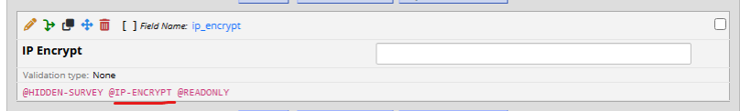

Source
This text box reads and outputs the end parameter of the survey link after the word ‘source’. For example: www.redcap.com/xyz&source=google will output ‘Google’. 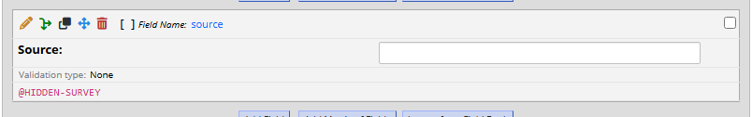
Twilio A2P 10DLC Consenting Language
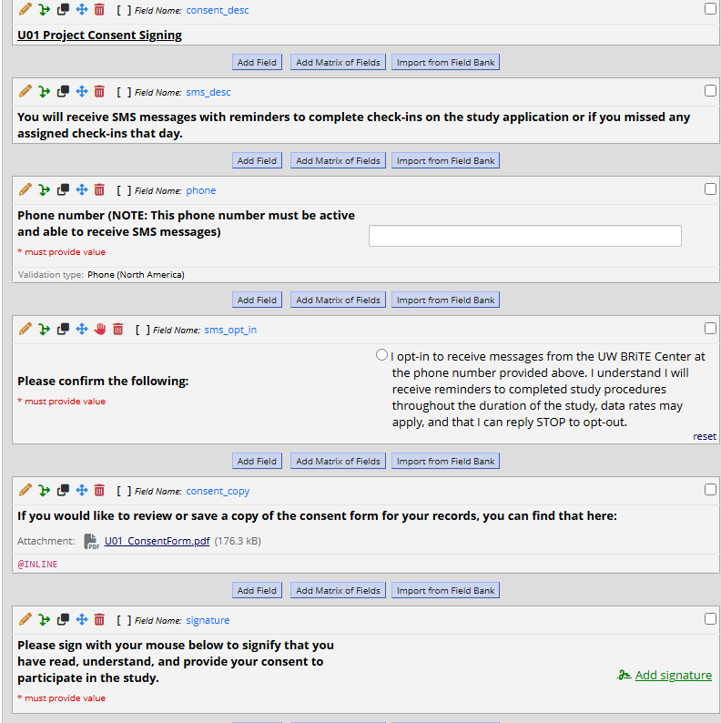
Use this language/format if you need to submit a new number for Twilio A2P 10DLC verification and are asked to explain how users opt in.
@INLINE shows the PDF in the survey rather than as an attachment.

Calculating Time Difference
- @NOW calculates the time on the user’s device when they completed the survey.
- @NOW-SERVER calculates the local time where the server is located (in our case, Seattle).
- Time Difference is calculated using the datediff function by subtracting user time from server time and outputting the discrepancy in hours -
  - datediff ([server_time], [user_time], "h", true)
- Rounded Time Difference is calculated using the round function that rounds down the time difference to the nearest integer -
  - round([timediff])
- @HIDDEN-SURVEY keeps the item hidden from participants when they fill out the survey, but accessible in the record view.
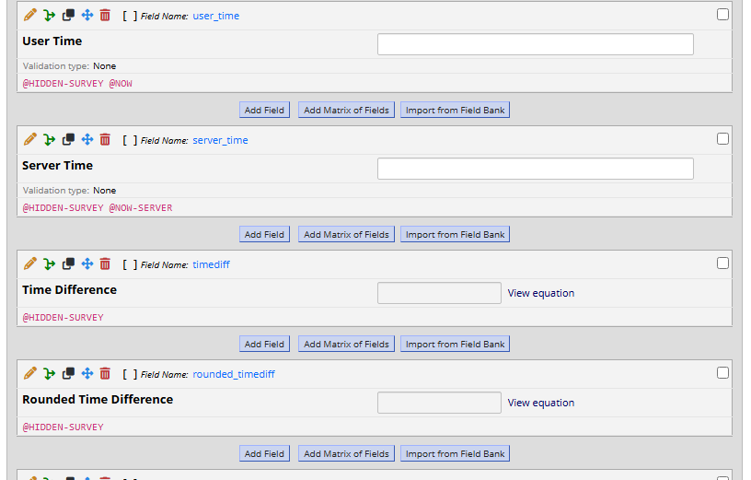
Time Zone Correct
This variable in the Screener instrument subtracts their self-reported time zone from the calculated rounded time difference. The resulting value will be 1 IF the time zone is reported correctly OR 0 if it’s incorrect.
Note: Time zones are appropriately numbered in the previous self-report item to help with this calculation (e.g., 0 for PST, 3 for EST, -3 for Hawaii time, etc.) so that the resulting value after subtraction will be 0 if the inputs match.
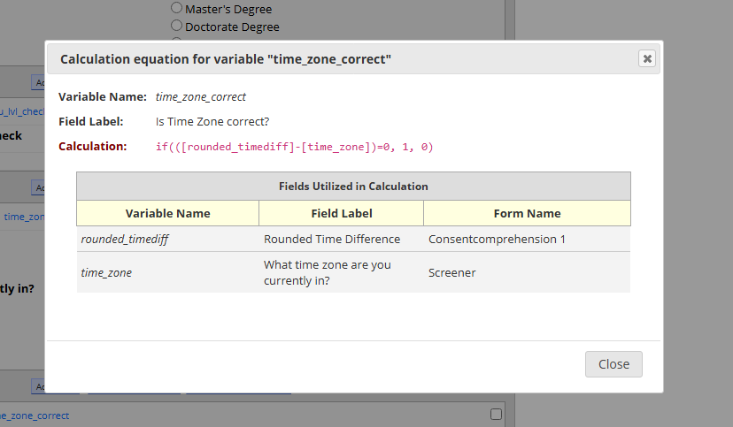

Age Calculations
Calculated Age from DOB (age_calculated) is done using the datediff function, subtracting their entered date of birth from today’s date.
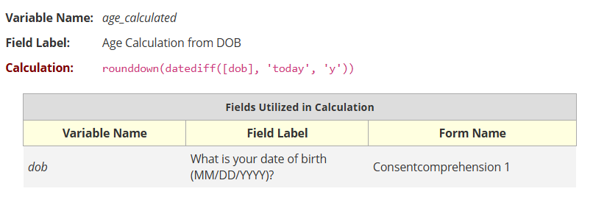
Age consistency check (age_compare) will output ‘1’ if the self-reported age matches the age calculated above.
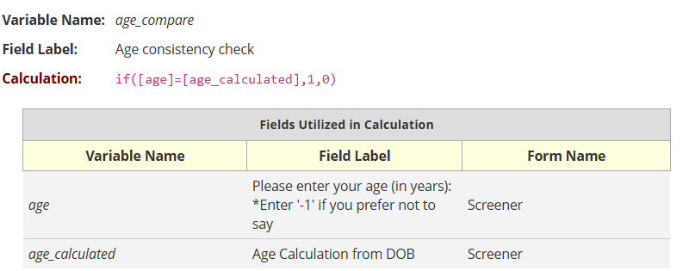

Determination Log Calculations
These will output 1 if the individual passes or 0 if they fail it.
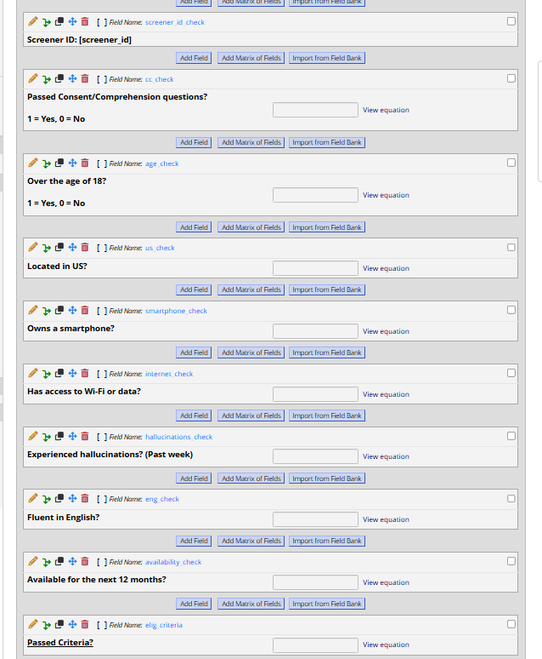
- Passed Consent/Comprehension will only output 1 if they scored exactly 9 in one of the previous consent/comprehension surveys.
  - if([cs1]!=9 and [cs2]!=9 and [cs3]!=9,0,1)
- Age: if([age]>=18,1,0)
- Located in US: if([live_us]=1,1,0)
- ‘Own a smartphone’ will output 1 if they selected the appropriate responses in the two Screener questions about phone use.
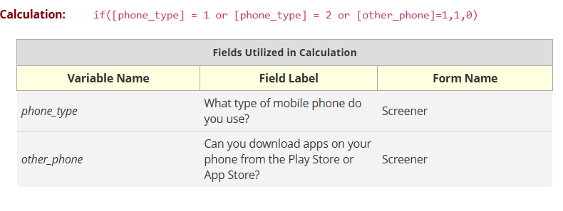
- WiFi or Date: if([internet_access]=1,1,0)

- ‘Experienced hallucinations’ will only output 1 if they endorse more than weekly visual or auditory hallucinations (response items 3 or 4)
  - 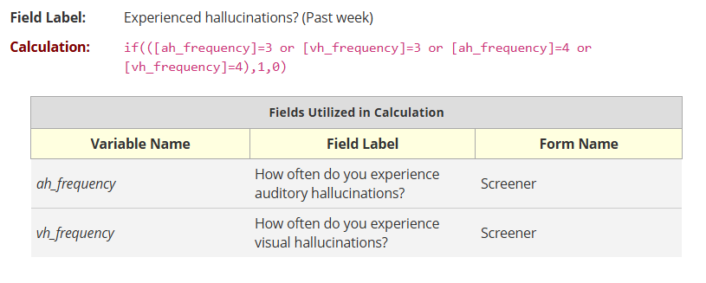
- English: if([english_proficiency] = 1,1,0)
- Available for next 12 months: if([availability] = 1,1,0)
- ‘Passed Criteria’ will output 1 if they pass all the items.
  - 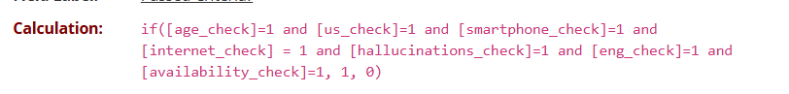
Attention Check
This will output 1 if they answer each attention question correctly, else 0.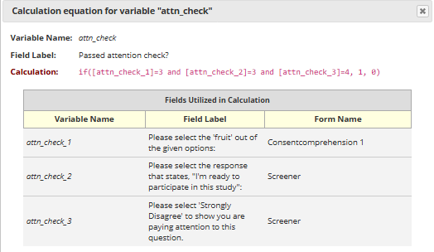
Time Zone Check
‘Time Zone Difference’ shows how much the self-reported time zone differs from the calculated time difference. It’s the same calculation used for the Screener’s ‘time_zone_correct’ variable, without the if-statement.
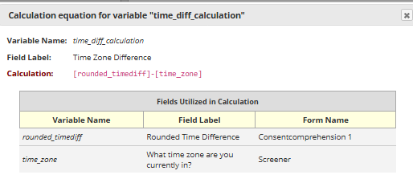
‘Passed Time Zone Check’ is also based on the Screener’s ‘Time Zone Correct’ variable and will output 1 if the self-reported and calculated values are consistent.
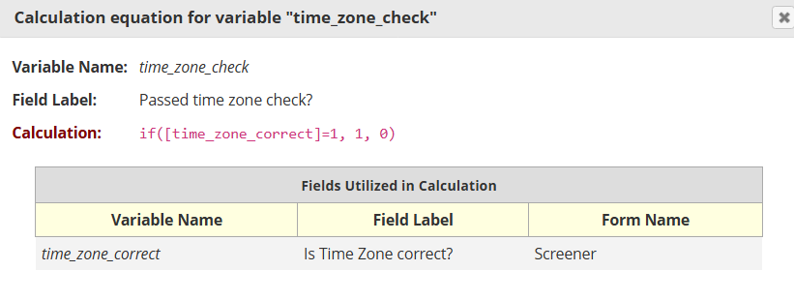

Duplicate Check
The Duplicates report under Data Exports, Reports, and Stats surfaces fields that tend to recur across repeat or fraudulent submissions (contact details, device identifiers, or the payment details used for incentives). Use the search bar to confirm that any new entry is a new person.
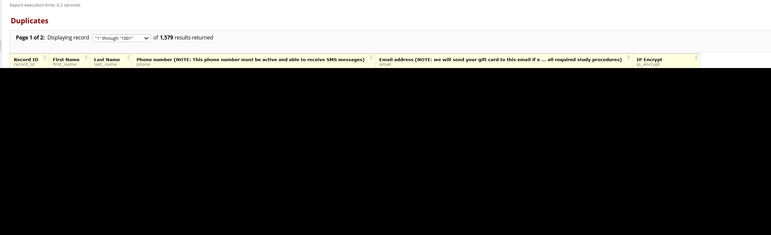
Consistency Check
The 'Consistency Check' report will list variables on age, location (zip code and city), and education level. The individual passes the check if the values are consistent
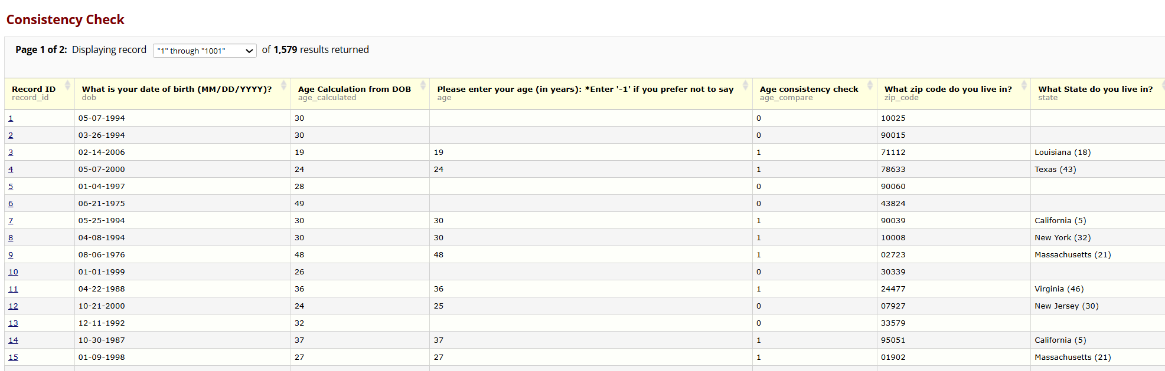
This information is now also in the individual participant’s Determination Log (under the ‘Consistency Check’ section) so that it’s easier to track.

Honeypot Check
The logic in this is reversed, so it will output 0 if the honeypot question was answered (presumably by a bot) and 1 if it was left blank. We flag anything that outputs 0.
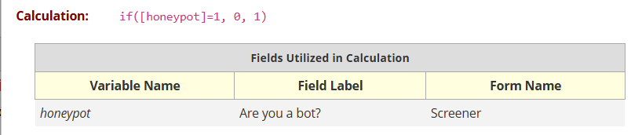
This field includes an @HIDDEN action tag so if it's filled for any reason that means it was most likely done by a bot as regular people wouldn't be able to see it.

Final Eligibility
After you complete the initial eligibility review and any necessary phone screens, you are ready to make a decision on the participant.
Selecting ‘Yes’ to ‘final_elig’ will display the ‘Participant ID’, ‘SBM Username’, and ‘GUID/pseudoGUID’ items (the latter is in the GUID section).
Selecting ‘No’ will display the ‘Reason for ineligibility’ item.
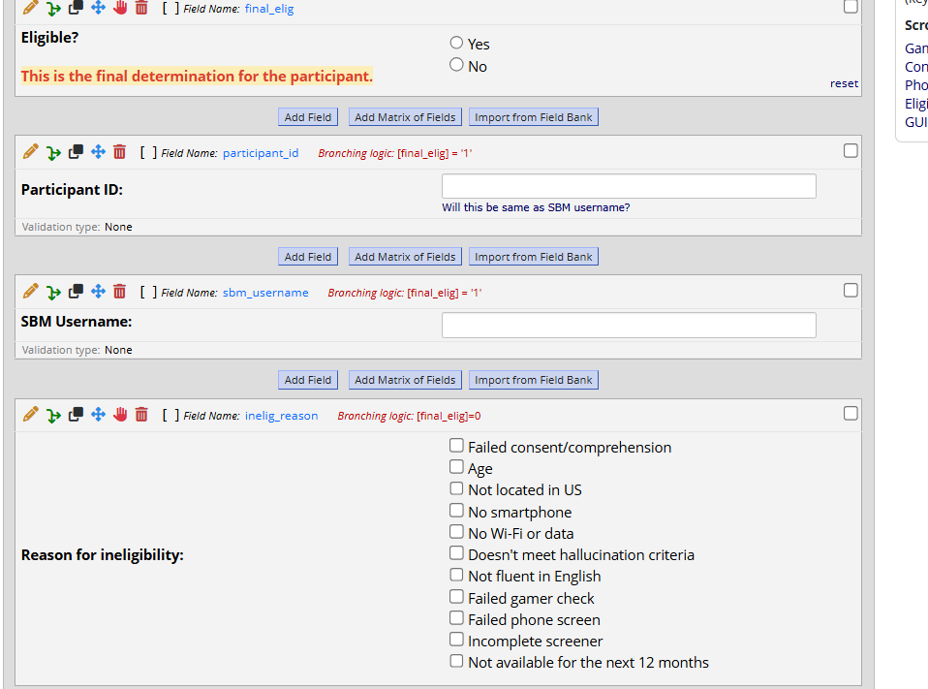

Smart Graphs
In Project Dashboards, we can create graphs and tables that update in real time.
Use the ‘Wizard’ feature to select the smart variable (this includes basic calculations like sum/average/etc. or graphs such as bar, donut, and pie charts) and the relevant field.
You can also limit these to specific reports by indicating the report ID with the function.
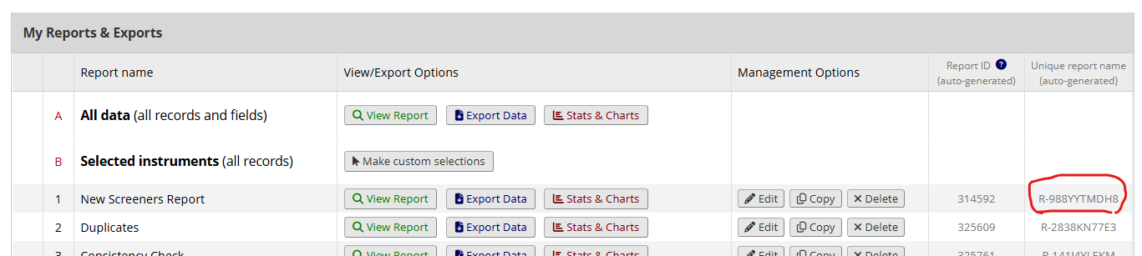
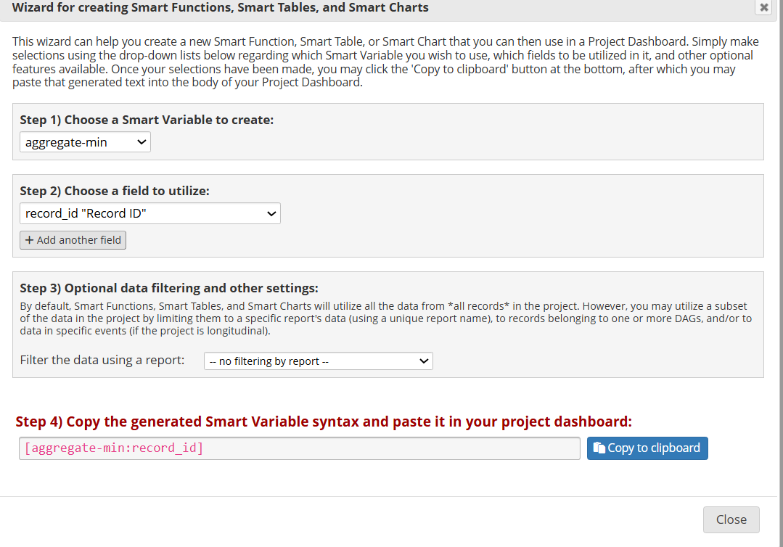
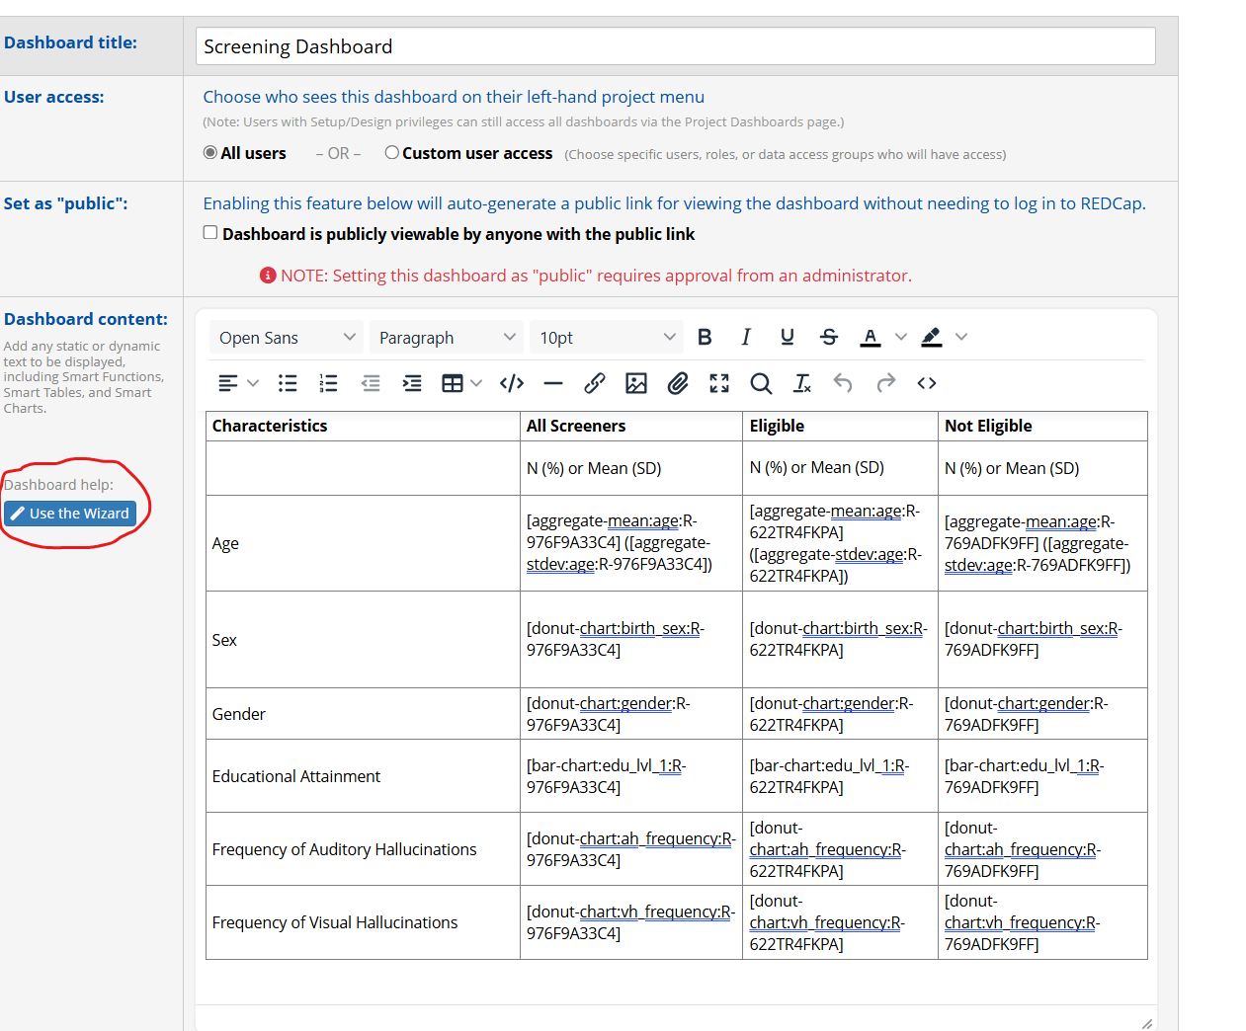
Setting up e-consent and locating IPs
To collect full IP addresses directly in REDCap, we need to enable the e-Consent framework in our consent form.
Go to the Screener REDCap -> Designer -> click on ‘e-Consent’
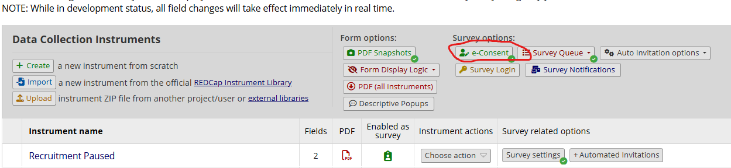
Select the green ‘+ Enable for a survey’ and choose the survey where you’re collecting consent (name and signature).
Select ‘Edit Settings’
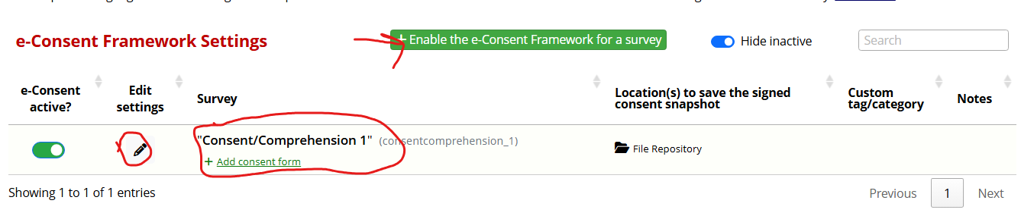
Select the corresponding First and Last Name fields. You can ignore the rest of the settings.
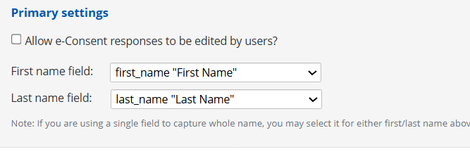

Ensure ‘Save to File Repository’ is selected and then save the settings.
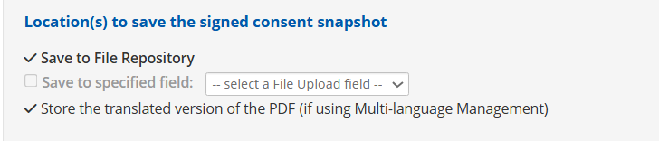
People filling out the consent form will now be provided with an option to review their responses in a PDF after they fill it out. They will be asked to select a button confirming that they want to share this information before they hit Submit.
To locate the IPs, click on File Repository -> PDF Snapshot Archive.
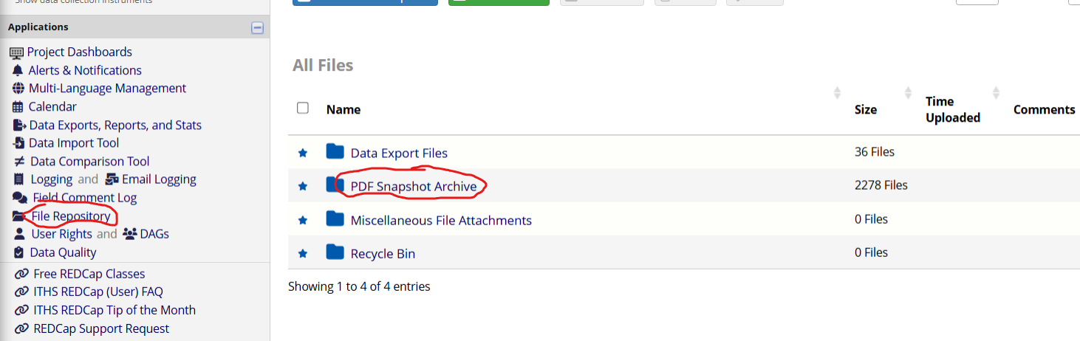
Longitudinal Database
Assigning Instruments to Events
Once an instrument has been enabled as a survey in the Designer, you need to assign it to the relevant event(s).
To set up your events, go to Project Setup -> Define My Events. We have 6 events in the Longitudinal Database.
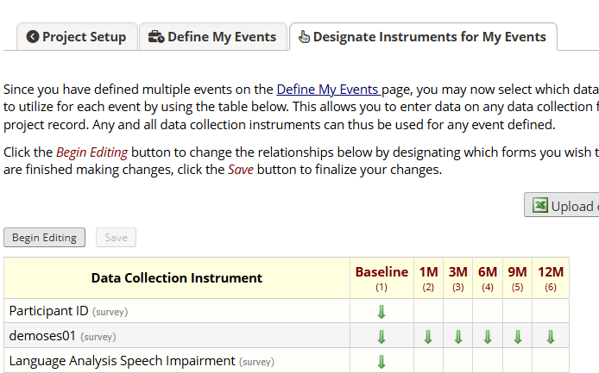
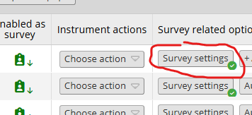
Auto-continue Surveys
If you go into the ‘Survey Settings’ of a particular instrument in the Designer, you can change various features of the survey including font, background color, enhanced buttons, and other customizations.
At the bottom, there is a tab for survey termination. Selecting ‘auto-continue’ allows users to automatically move on to the next instrument in the event.
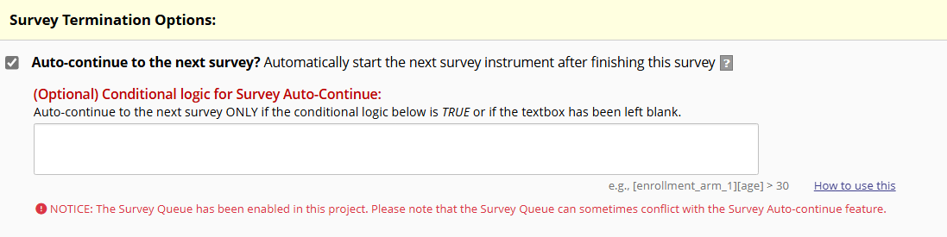

Note: You do not need to set up a survey queue if you use this strategy.
If you go to Project Setup -> Designate Instruments for My Events, you will now see arrows pointing down for the instruments with auto-continue. When a participant completes an instrument, they will be automatically shown the next instrument that has been assigned to that event.
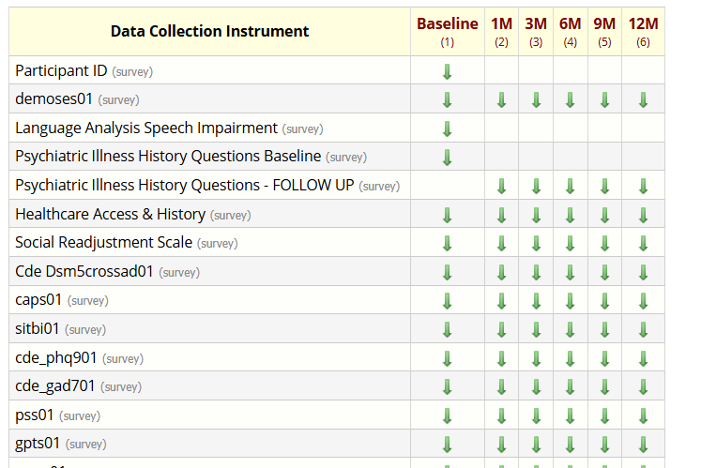

Auto-Continue for Suicide Response
The final survey (EASI) also has conditional logic so that only those who endorse suicidal ideation in previous instruments are shown the following Suicide Response instrument. Participants will auto-continue to Suicide Response only if they selected certain responses, otherwise, they are just provided the thank you message at the end.
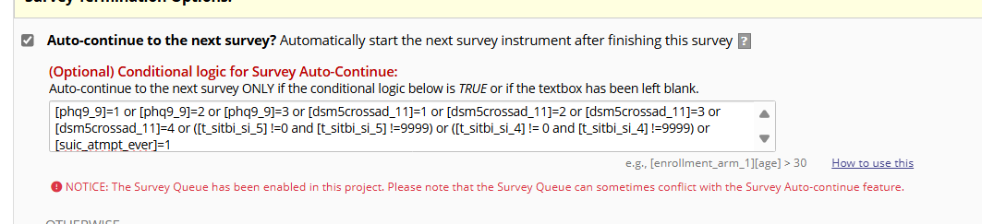
Survey Queue for NDA form and Completed Event Messages
We have enabled the survey queue for the NDA form (‘Submit Data’) and for the Completed Event Messages instruments.
Considering that participants can end on either EASI or Suicide Response as their final survey, we cannot use the auto-continue feature. Instead, we’ve set completing EASI (26 of 26) as the requirement in the survey queue so that the participants will get the NDA instrument regardless of whether they do the ‘Suicide Response’ survey or not. Auto-continue takes priority over survey queue, so if a participant endorses suicidal ideation, they will still see the Suicide Response instrument before the NDA form.
The ‘Thank You’ message follows the NDA form and is the final instrument. There is no NDA form in the other events, so the Thank You messages will just follow the EASI survey of the corresponding event.
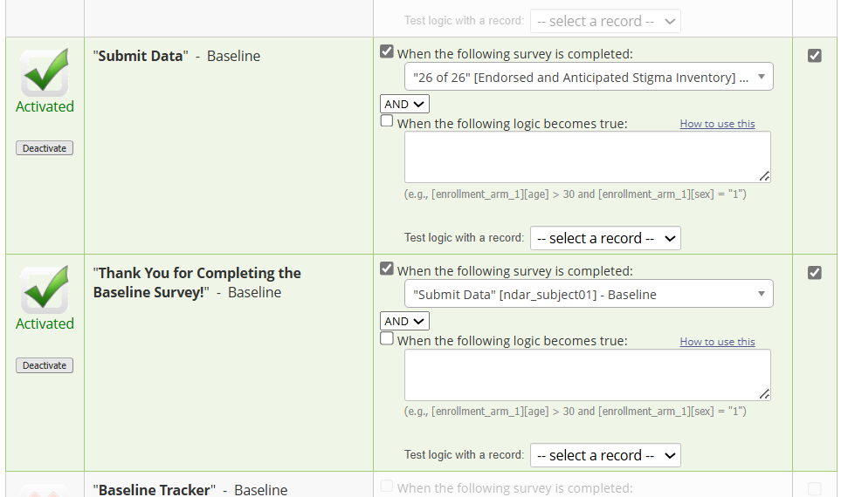
NDA Form
The NDA form is saved directly by participants at the end of baseline. It uses various hidden fields (calculations and piped values) that are not seen by participants. They only see the final message ‘submit_instructions’.
@DEFAULT tag is used to output a constant value or a piped value using data submitted by the participant in previous instruments.
For example, @DEFAULT='[baseline_arm_1][guid]' or @DEFAULT='UWash'
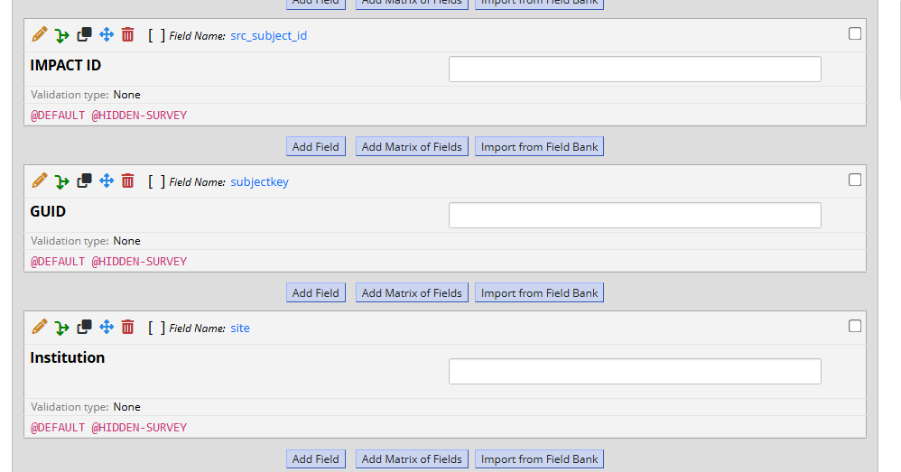
@CALCTEXT tag can be used to output text.
You can choose to set constants – for example, @CALCTEXT('No') - or use if-functions within the tags as well.
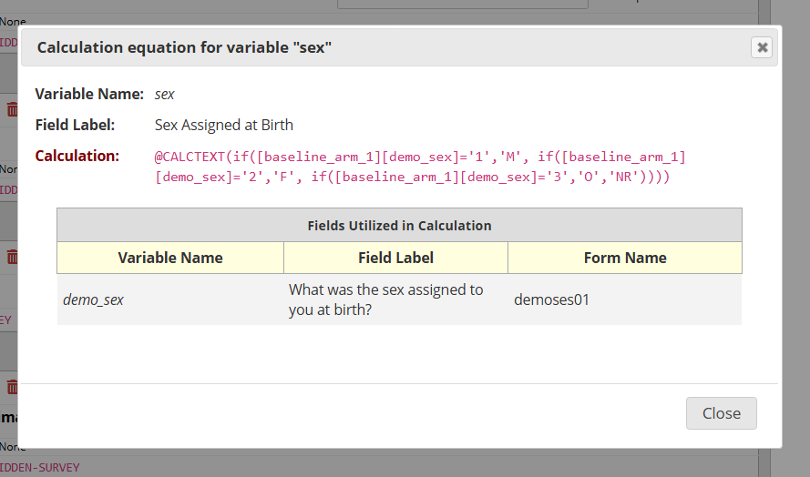
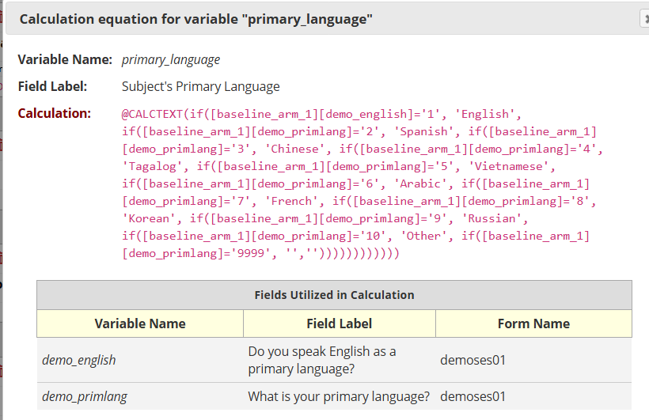

If-statements can also be used to set defaults. For the Study Status and Lost to Follow-up variables, we have set ‘Active’ and ‘No’ respectively as the ‘else’ values. This way, the defaults are still displayed even if no value is chosen in the previous item.
In this example below, only by selecting ‘Yes’ will the subsequent value change as well. Not selecting anything will preserve the ‘No’.
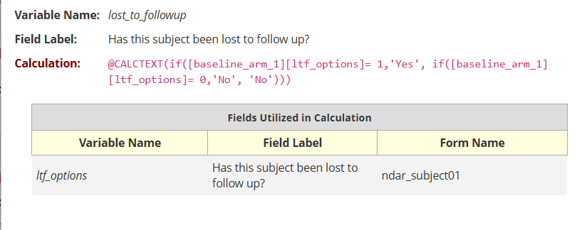
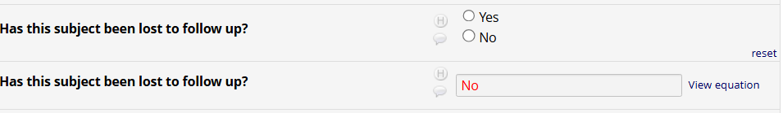
For reference, calculations used in ndar_subjects_01:
- Sex: @CALCTEXT(if([baseline_arm_1][demo_sex]='1','M', if([baseline_arm_1][demo_sex]='2','F', if([baseline_arm_1][demo_sex]='3','O','NR'))))
- Race: @CALCTEXT(if([baseline_arm_1][demo_race(9999)] = '1', "Unknown or not reported", if(([baseline_arm_1][demo_race(1)] + [baseline_arm_1][demo_race(2)] + [baseline_arm_1][demo_race(3)] + [baseline_arm_1][demo_race(4)] + [baseline_arm_1][demo_race(5)] + [baseline_arm_1][demo_race(6)] + [baseline_arm_1][demo_race(7)] + [baseline_arm_1][demo_race(8)] + [baseline_arm_1][demo_race(9999)]) > 1, "More than one race", if([baseline_arm_1][demo_race(1)] = '1', "American Indian/Alaska Native", if([baseline_arm_1][demo_race(2)] = '1', "Asian", if([baseline_arm_1][demo_race(3)] = '1', "Black or African American", if([baseline_arm_1][demo_race(4)] = '1', "Other", if([baseline_arm_1][demo_race(5)] = '1', "Native Hawaiian or Pacific Islander", if([baseline_arm_1][demo_race(6)] = '1', "White", if([baseline_arm_1][demo_race(7)] = '1', "Other", if([baseline_arm_1][demo_race(8)] = '1', "Unknown or not reported", "Other")))))))))))
- Ethnicity: if([baseline_arm_1][demo_hispanic]='1','1',if([baseline_arm_1][demo_hispanic]='0', '0',""))
- Primary Language: @CALCTEXT(if([baseline_arm_1][demo_english]='1', 'English', if([baseline_arm_1][demo_primlang]='2', 'Spanish', if([baseline_arm_1][demo_primlang]='3', 'Chinese', if([baseline_arm_1][demo_primlang]='4', 'Tagalog', if([baseline_arm_1][demo_primlang]='5', 'Vietnamese', if([baseline_arm_1][demo_primlang]='6', 'Arabic', if([baseline_arm_1][demo_primlang]='7', 'French', if([baseline_arm_1][demo_primlang]='8', 'Korean', if([baseline_arm_1][demo_primlang]='9', 'Russian', if([baseline_arm_1][demo_primlang]='10', 'Other', if([baseline_arm_1][demo_primlang]='9999', '',''))))))))))))
- Education: if([baseline_arm_1][demo_education]='9999', '', if([baseline_arm_1][demo_education]='1', '1', if([baseline_arm_1][demo_education]='30', '30', if([baseline_arm_1][demo_education]='31', '31', if([baseline_arm_1][demo_education]='16', '16', if([baseline_arm_1][demo_education]='16', '16', if([baseline_arm_1][demo_education]='17', '17', if([baseline_arm_1][demo_education]='19', '19', if([baseline_arm_1][demo_education]='20', '20', if([baseline_arm_1][demo_education]='21', '21', if([baseline_arm_1][demo_education]='22', '22', if([baseline_arm_1][demo_education]='23', '23', if([baseline_arm_1][demo_education]='24', '24', if([baseline_arm_1][demo_education]='29', '29', if([baseline_arm_1][demo_education]='999', '999', '' )))))))))))))))
- Employment: if([baseline_arm_1][demo_employment]='9999', '', if([baseline_arm_1][demo_employment]='1', '1', if([baseline_arm_1][demo_employment]='3', '3', if([baseline_arm_1][demo_employment]='4', '4', if([baseline_arm_1][demo_employment]='5', '5', if([baseline_arm_1][demo_employment]='6', '6', if([baseline_arm_1][demo_employment]='7', '7', if([baseline_arm_1][demo_employment]='8', '8', if([baseline_arm_1][demo_employment]='9', '9', if([baseline_arm_1][demo_employment]='10', '10', if([baseline_arm_1][demo_employment]='11', '11', if([baseline_arm_1][demo_employment]='12', '12', if([baseline_arm_1][demo_employment]='13', '13', '' )))))))))))))
- Study Status: @CALCTEXT(if([baseline_arm_1][state_options] = 1, "Ineligible", if([baseline_arm_1][state_options] = 2, "Eligible", if([baseline_arm_1][state_options] = 3, "Active", if([baseline_arm_1][state_options] = 4, "Withdrawn", if([baseline_arm_1][state_options] = 5, "Terminated", if([baseline_arm_1][state_options] = 6, "Expired", if([baseline_arm_1][state_options] = 7, "Special Population (Prison, etc).", if([baseline_arm_1][state_options] = 8, "Completed", "Active")))))))))
- Lost to Follow-up: @CALCTEXT(if([baseline_arm_1][ltf_options]= 1,'Yes', if([baseline_arm_1][ltf_options]= 0,'No', 'No')))
- Twins/Sibling/Family/DNA questions: @CALCTEXT('No')

Data Quality Rule H
Once a survey is submitted, it saves whatever calculated values it has at that time even if the calculation changes afterwards. These new values won’t appear in the exported dataset even if it looks like they’ve changed within the record itself. To update all values, we can go to the Data Quality tab and execute rule H.
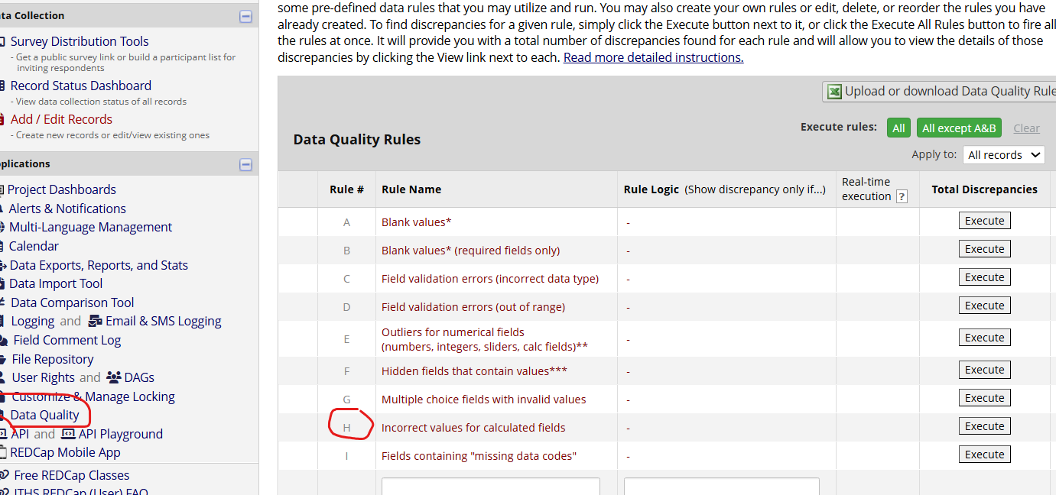

Click ‘Execute’ to scan all records and locate any calculated values that have changed since they were last saved. Once it’s executed, click ‘View’ to see all the changes.
You can choose to exclude any items that you don’t want to update. After excluding these, click ‘Fix calcs now’ to automatically update the values that are still in the list.
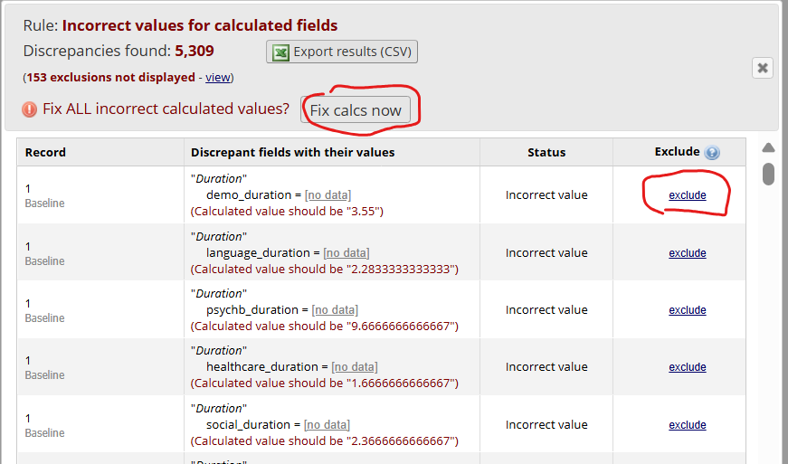

Sending Surveys to Participants
Click on Survey Distribution Tools -> Participant List. Make sure you’re on ‘Initial survey’.
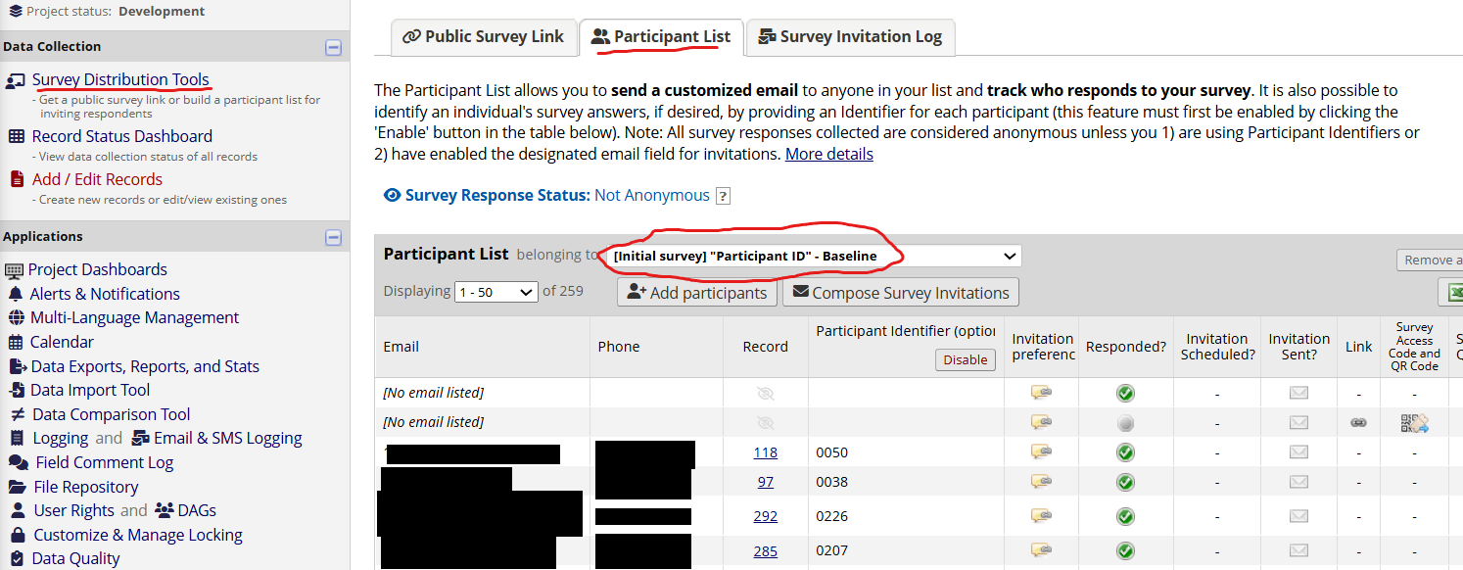
Click on ‘Add participants’ and include their contact information in the format provided.
- Email, Phone Number, Participant ID
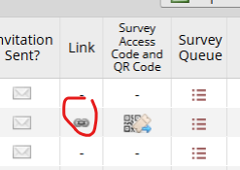
Once they’ve been added, click on the link icon next to their record.

Enter the participant details on the ‘Participant ID’ page and hit submit.
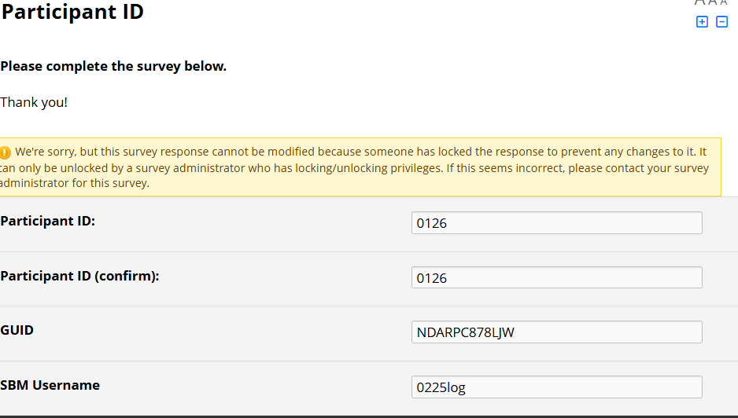

Go back to the Participant List, switch to the next survey in the order and then click ‘Compose Survey Invitations’.
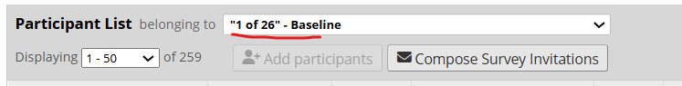
NOTE: You can also manually send links to specific instruments by selecting that particular instrument in the Participant List (2 of 26 - 1M, 3 of 26 – 3M, etc.) and composing the invitation from there. This will need to be done if a participant stops midway through an event but then ignores all their automated reminders.
In ‘Compose Survey Invitations’, select SMS invitation and schedule it to send ‘Immediately’. You can enable reminders to be sent as well; we generally send reminders every 2 days up to 3 times.
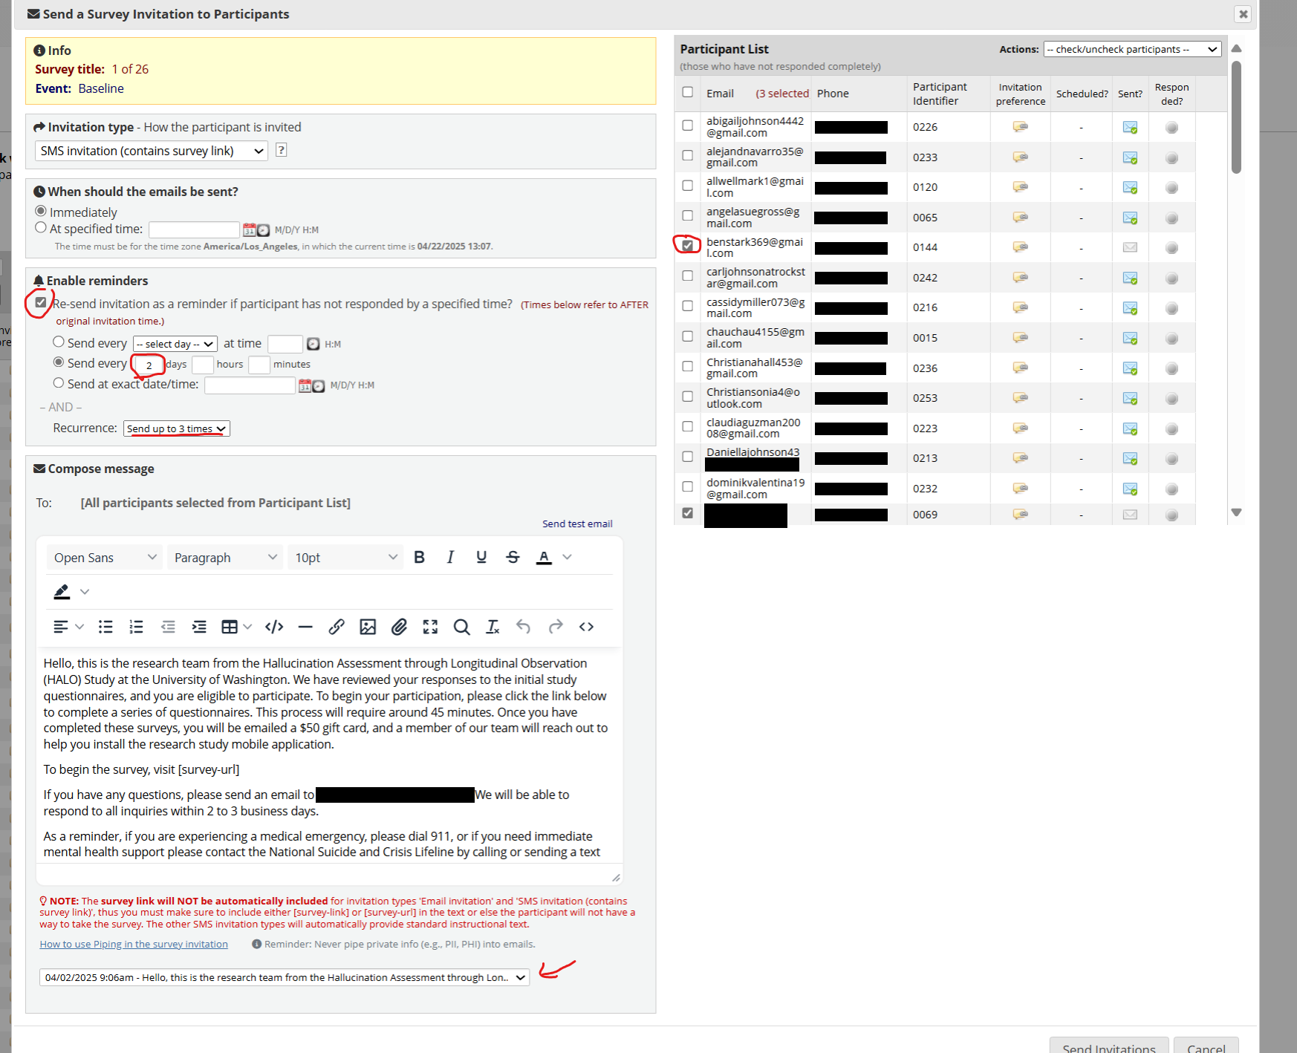

Choose a message from the drop down or write your own. Make sure the message includes [survey-url]
Select the participants you want to send it to from the list on the right. Double check that you aren’t accidentally sending it
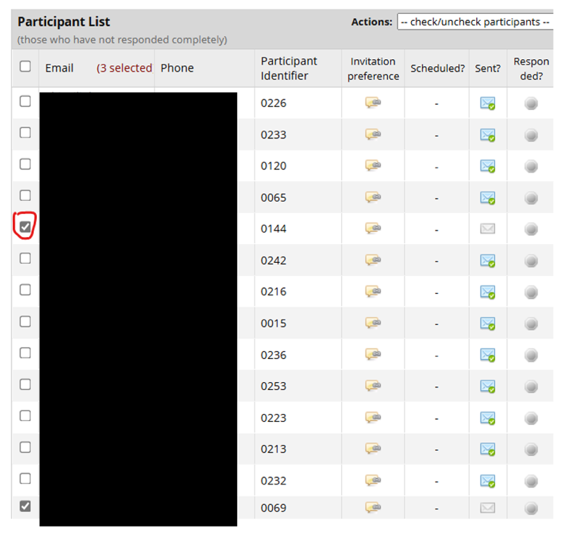
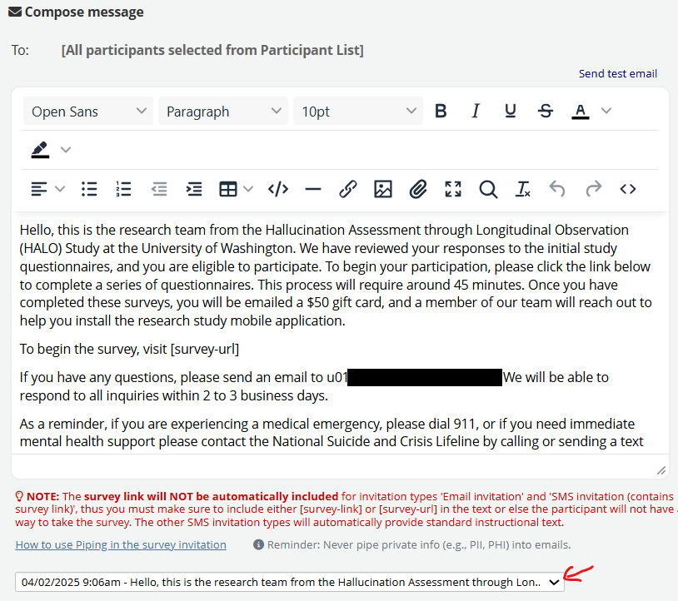

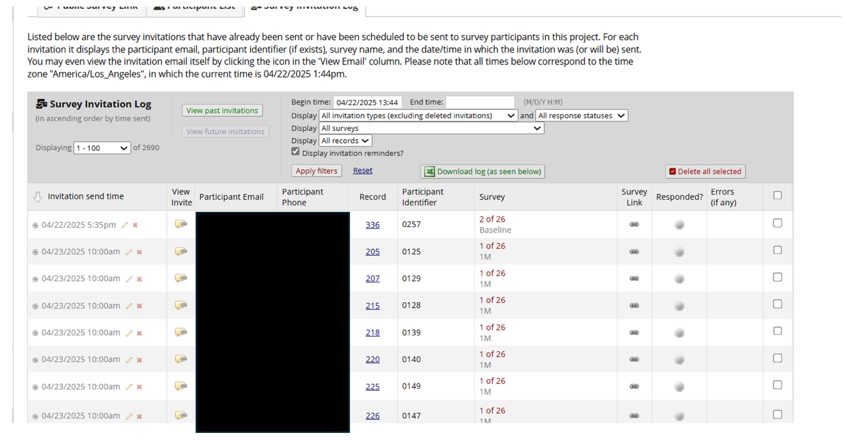
If you want to review, delete, or edit messages, go to the Survey Invitation Log. Here you can view past notifications, see if someone has responded, or modify the date/time of scheduled reminders.

Tracker Triggers
The trackers include triggers that send out various alerts and automated invitations once the RC selects them and saves the form. NOTE: These triggers will only be activated once the tracker form is marked with ‘Complete’ status.
Baseline Complete (Baseline only) -> triggers the branching logic in the demoses01 form to hide questions that we don’t want to ask again during the other timepoints.
Those items will only show during baseline, when [complete_baseline] is NOT equal to 1.
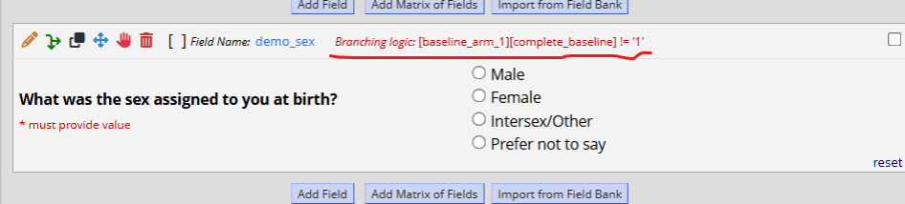
Send Follow-up (Baseline only) -> this trigger schedules the automated invitations to demoses01 for the 1M, 3M, 6M, and 12M events. NOTE: SBM start date needs to also be entered to schedule the subsequent timepoints.
Start SBM (Baseline only) -> this sends the SBM installation instructions via email. NOTE: enter participant’s SBM username and password prior to saving the form as well.
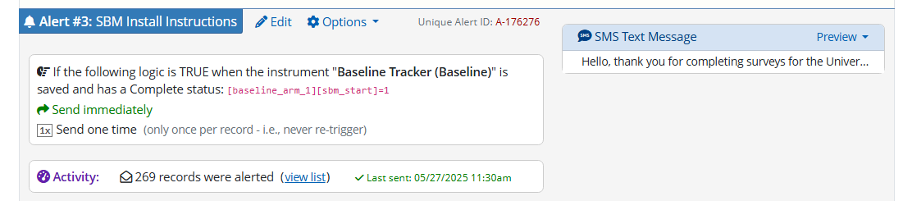
Username is piped directly in the email as [baseline_arm_1][sbm_username].
Send Incentive (all trackers) -> this sends gift card details to participant via email. NOTE: The Incentive URL needs to be entered in the tracker prior to saving the form with ‘Complete’ status.
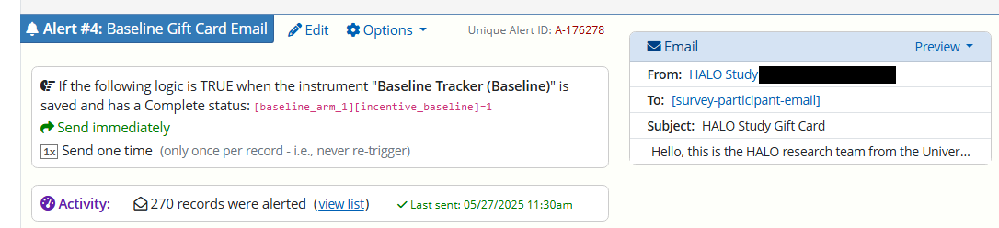
Reason for Discharge (all trackers) -> if you select ‘(3) lost to follow-up’, participants are sent an email letting them know.
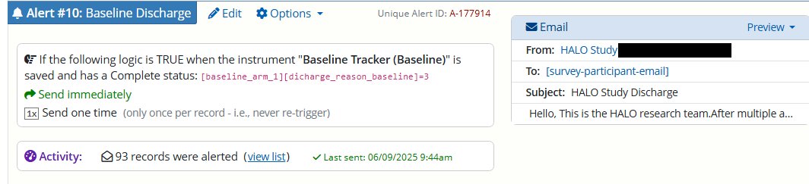
# of Days Past Install
This variable captures how many days it’s been since their start date (SBM install date) using the datediff function.
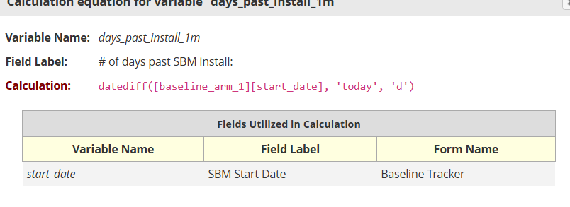
Should RC outreach?
If it’s been > 7 days since their next timepoint survey was due and they haven’t completed it yet (which suggests that they missed all their automated reminders), this variable will display ‘Yes’.
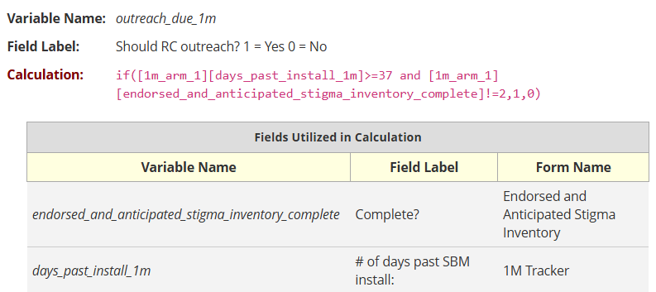

Suicide Trigger
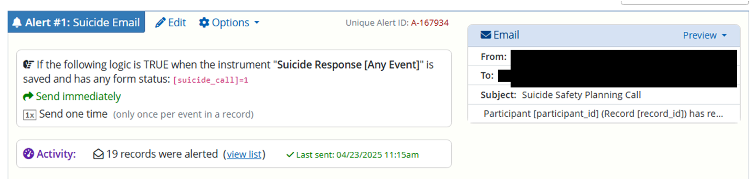
Unlike the other alerts that trigger once per record, this one will trigger once per event per record as participants can potentially request a call at multiple timepoints. This email is triggered if the participant responds ‘Yes’ to a phone call from the research team ([suicide_call]=1) in the Suicide Response instrument.
Automated Invitations
We send automated messages with the relevant survey link to participants 1) at the next scheduled timepoint and 2) if they stopped the survey midway during the same timepoint.
We can set this up using ‘Automated Invitations’ in the Designer.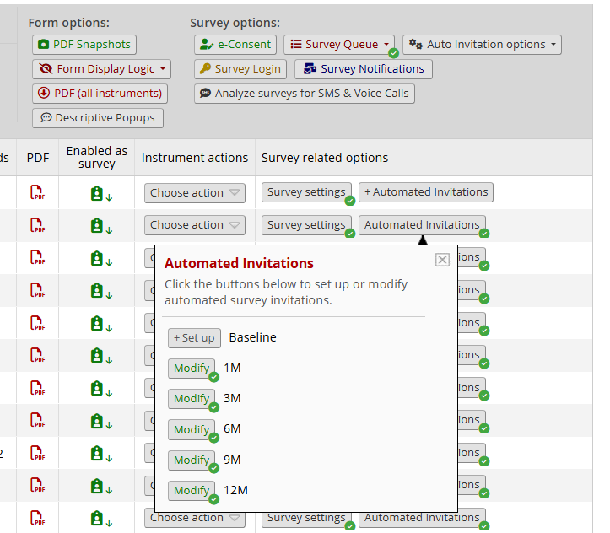
The message for the next scheduled timepoint is set in demoses01 (the first survey). The message is triggered after the Baseline Tracker is marked as complete and the RC has selected ‘Yes’ to ‘Send follow-up?’.
The message can be scheduled to trigger X number of days after the SBM start date indicated in the Baseline Tracker (30 for 1M, 90 for 3M, etc.)
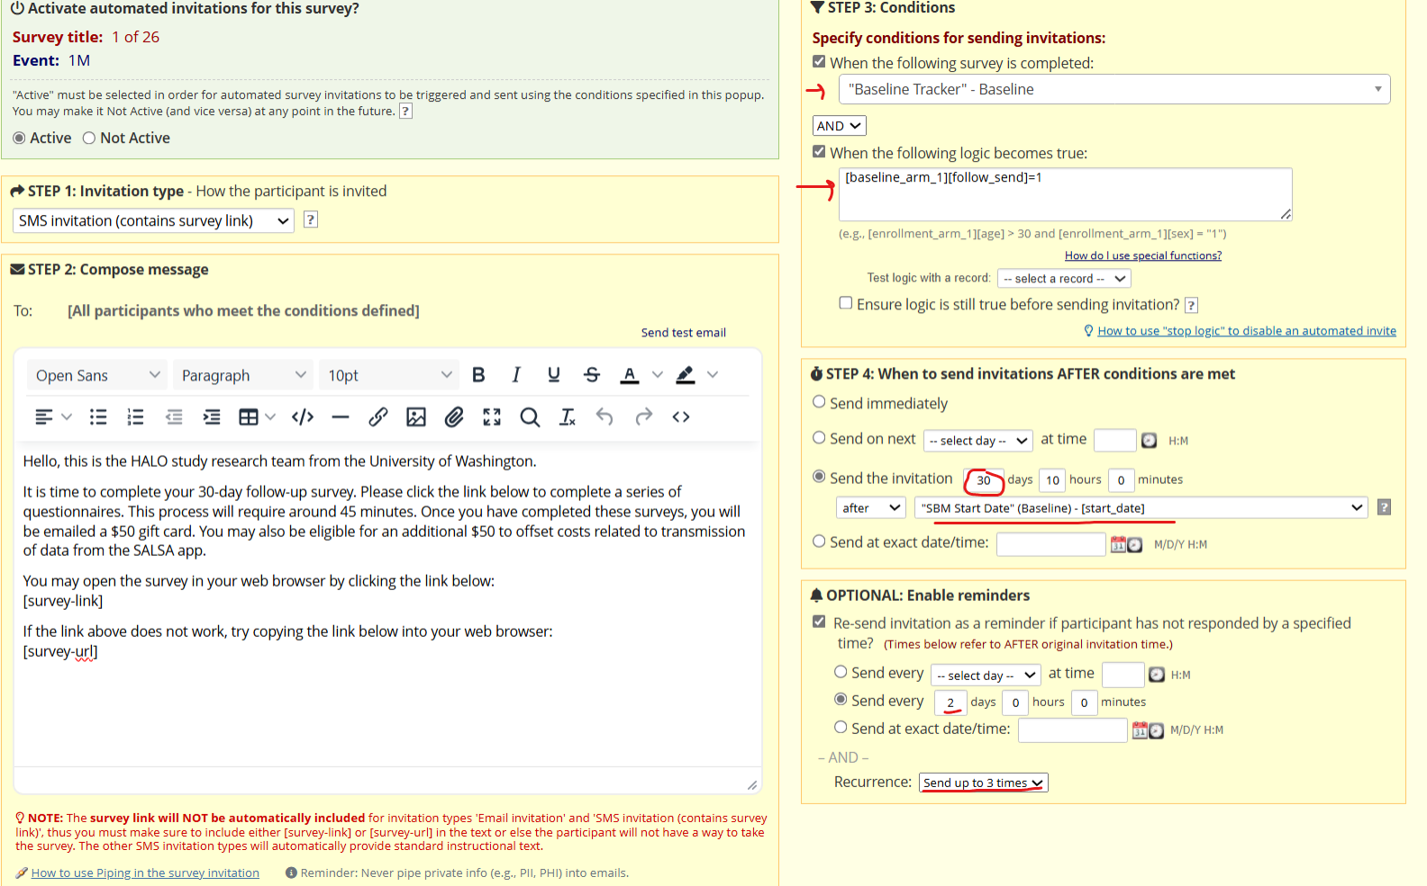
The mid-point reminders need to be set for every instrument across all timepoints.
To trigger these, a participant needs to have the previous survey completed and the current survey incomplete (!=2). Make sure that the correct survey from that timepoint is being used when you specify conditions and that you use the appropriate timepoint names in the logic (1m_arm_1, 3m_arm_1, etc.)
We schedule the invitation to be sent after 1 day to make sure that the gap between instruments is because the participant actually stopped filling out the survey and not just because they took a short break.
We also enable ‘ensure logic is still true before sending invitation’ so that the reminder doesn’t get sent if the participant fills out the survey in time.
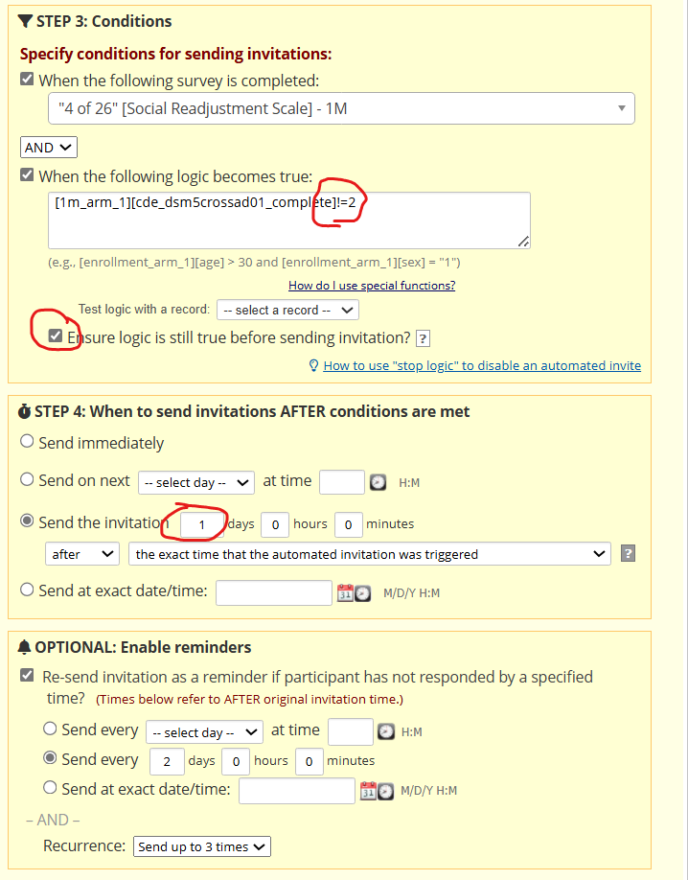
NOTE: Make sure the message is customized for each timepoint appropriately (incentive amount, etc.)
We enable reminders for all automated invitations to be sent every 2 days up to 3 times.

